 |  | 
Faculty of Technology and Engineering
Chandubhai S. Patel Institute of Technology (CSPIT)
Department of Computer Science & Engineering
Date: 30/09/2026
Laboratory Manual
Academic Year | : | 2026-27 | Semester | : | 3rd
Course code | : | ITUE203 | Course name | : | WEB DEVELOPMENT FRAMEWORKS

Practical – 8
MySQL Schema Design, ER Model, PDO Connectivity, and Prepared Statements
Problem Statement:- Design the database for StudentHub with students, events and registrations. Create PHP database connection using MYSQL statements

Objective:- The objective of this practical is to design a MySQL database schema for the StudentHub system.It includes creating tables for students, events, and registrations with appropriate relationships.
An ER model is developed to represent the structure and relationships between the entities.
PHP PDO connectivity is implemented to establish a connection between the application and MySQL database.
Github Repository Link:-
https://github.com/Nishtha-cse/StudentHubPortal-D26CS12

Screenshot
SQL Dump
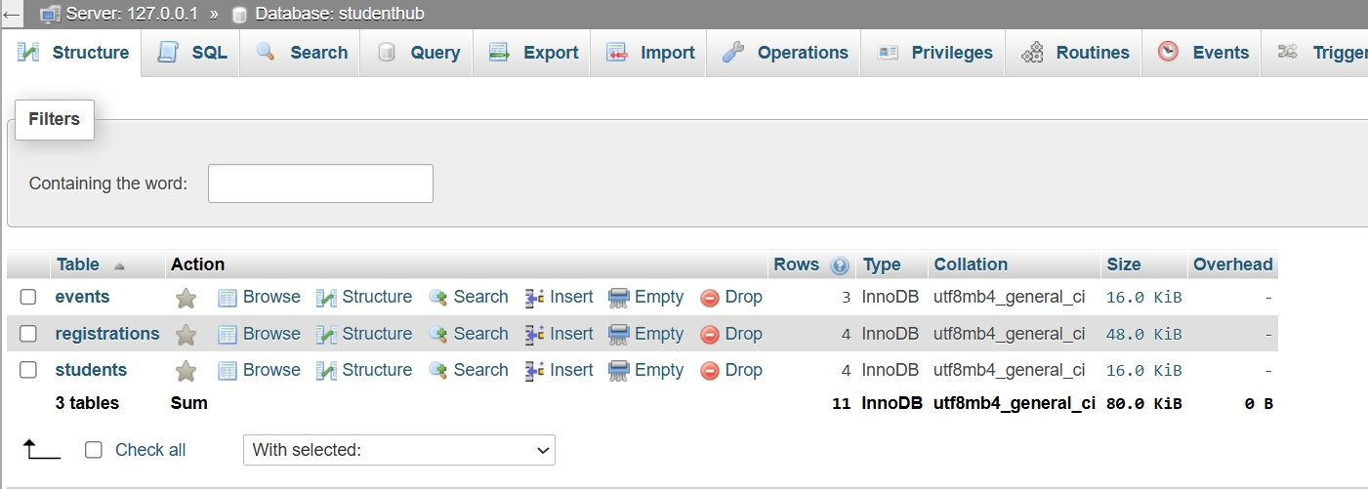
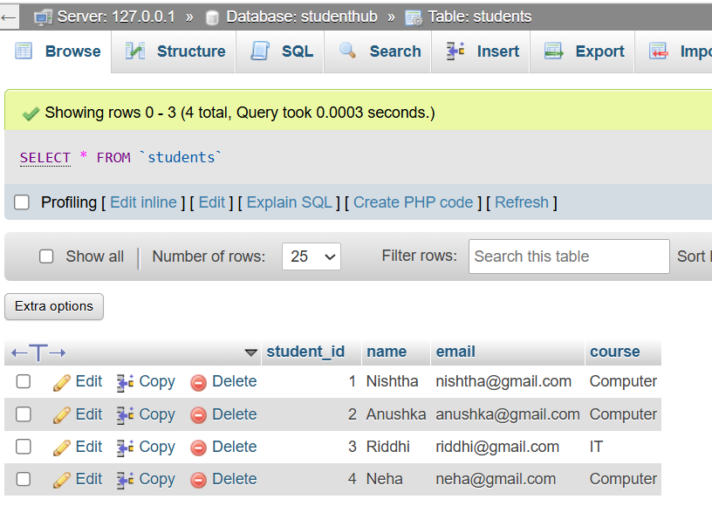

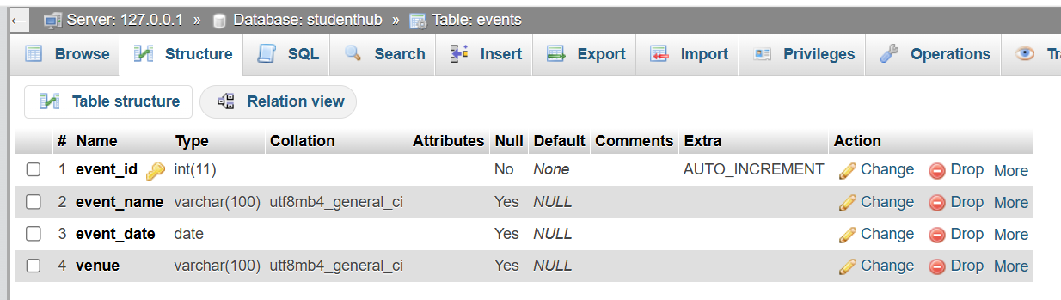
Code:
Db.php
<?php
$host = "localhost";
$dbname = "studenthub";
$username = "root";
$password = "";
try {
$pdo = new PDO(

"mysql:host=$host;dbname=$dbname",
$username,
$password
);
echo "Database Connected
Successfully";
}
catch (PDOException $e) {
echo "Connection Failed";
}
?>

Screenshot :
Connection screenshot :
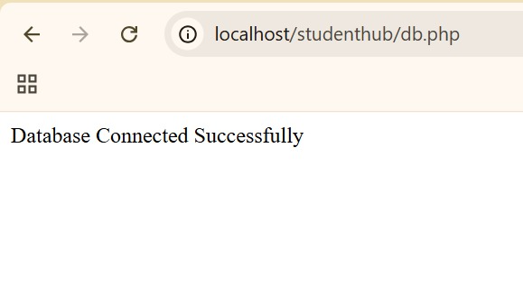

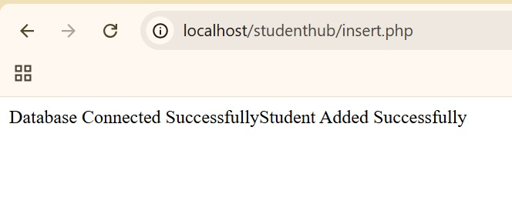

Learning outcome :
After completing this practical, I will be able to:

Design a MySQL database schema for the StudentHub system.
Create and manage tables for students, events, and registrations.
Understand and represent relationships between entities using an ER model.
Establish a database connection between PHP and MySQL using PDO.
Use prepared statements to execute SQL queries securely.
Understand the importance of database security and efficient data management in web applications.

